1 - Fundamentals Of Testing

## > Objectives of Testing

These are some of the main objectives of testing:

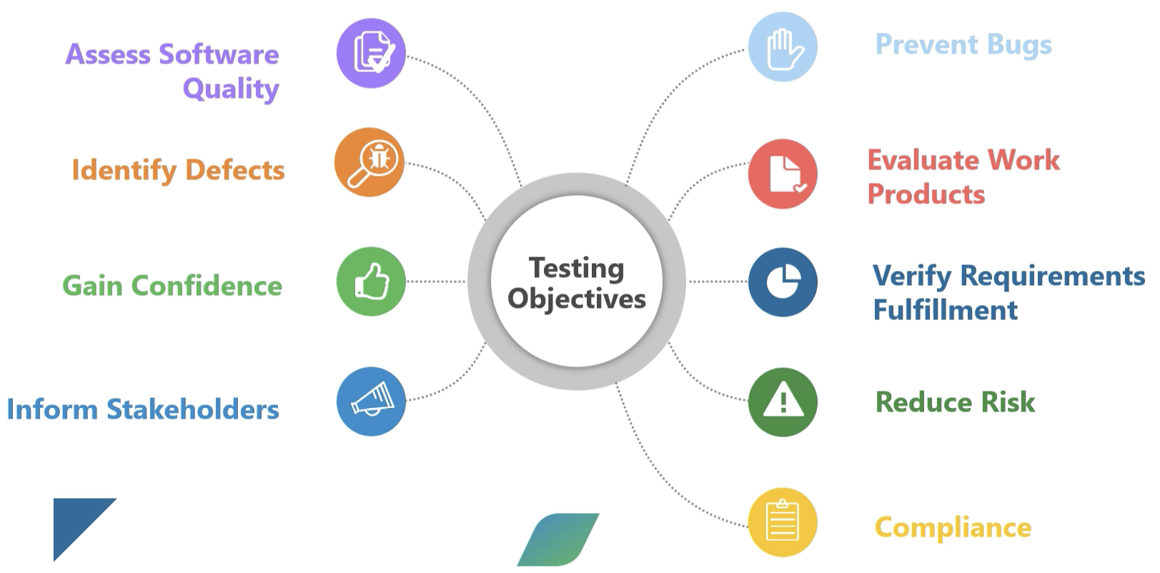

## > Quality Assurance vs Testing

**QA** - The process of how, who, when and where make testing.

**Testing** - The activity of testing.

## > Errors, Defects, Failures

*A person makes an error That creates a defect That causes a failure in operation*

Error: The **root cause** of the defect.

Defect: A **deviation** of the requirements.

Failure: If the code with a defect is **executed**, this may cause a failure.

Example:

Error: A person **misunderstood** a requirement.

Defect: That misunderstanding makes a person create a defect in the **code**.

Failure: That causes an incorrect program behavior in **prod**.

Defects could be:

- Functional

- Non Functional (Acceptance, Performance, Security)

## > 7 Principles of testing

* Testing shows the presence of defects, not their absence
* Exhaustive testing is impossible
* Early testing saves time and money
* Defect Cluster Together. Pareto Principle 80/20
* The pesticide paradox
* Test is context dependent. Different testing is necessary for different circumstances.
* Absence of error is a fallacy.

## > Testing and Debugging

**Testing or executing test cases:** can show failures that are caused by defects in the software.

**Debugging:** is the development activity that finds, analyzes and **fixes** such defects.

**Test Condition** - Any part of the software that **needs to be tested**; any function, transaction, feature or attribute of the system.

**Test Case** - A set of input values, preconditions, expected results and postconditions, developed for a particular objective or **test condition**.

**Test Suite** - A group of **test cases** for a specific module or purpose.

## > Test Process

1. Test Planning
2. Test Monitoring and Control
3. Test Analysis
4. Test Design
5. Test Implementation
6. Test Execution
7. Test Completion

### Planning:

During this phase we work on answering the following questions:

**What** to test,

**Who** would do testing

**When** we are going to start testing

**How** are we going to do testing

The main purpose is to create a big picture plan about how testing activities should work

### Monitoring and Control:

Common activities to do during this phase:

* Comparing actual progress against the test plan
* If any deviation, then take **any necessary action** to stay on track to meet the targets (a.k.a. Test Control)
* During this phase we evaluate the **exit criteria** against the **defined objectives**

Examples of **Exit criteria:** Test Coverage, Status about fixing defects, risk to make a deployment

### Test Analysis:

During this phase we focus on answering this question: **What to Test?**, in other words, we work on defining the **Test Conditions**.

Activities during the test analysis includes check **test basis** so that we can find defects like:

* Ambiguities
* Omissions
* Inconsistencies
* Contradictions

Examples of **Test Basis**:  
 - Docs with requirements specifications (Jira tickets)

- Docs with design and implementation information (Architectural Diagrams)

- The implementation of the component or system itself

- Risk analysis reports

### Test Design

During this phase we focus on answering this question: **How to Test?**, in other words, we work on defining the **Test Cases.**

During test design test conditions are elaborated into high level test cases, sets of test cases and other test things.

### Test Implementation

During this phase we focus on answering this question: **Do we have everything in place to run the tests?**, in other words, we work on creating **Test Procedures**.

* Prioritizing test cases
* Create automated test scripts
* Create tests suites
* Schedule test execution
* Build test Environment

### Test Execution

During this phase we focus on the next activities:

* Running Test Suites on a specific schedule.
* **Results** need to be compared against **Expected Results**.
* **Create Bug Reports** if there is a failure.
* Running Manual or automated tests

### Test Completion

During this phase we focus on the next activities:

* Ensure documentation is in order
* Report defects closed
* Creating a test summary report
* Delete confidential data
* Analyzed lessons learned

## > Test Work Products

**Work Products: Represents the output of an activity**

Test work products represent **all the documents**, reports and material created **during** the **Test Process.**

Some outputs of testing activities are:

* Test Plans
* Test Cases
* Test Results
* Bug Tickets
* Tests Reports
* Test Suites
* Automation Scripts

Traceability between the **Test Basis** and **Test Work Products**

One of the most common ways to create a good traceability between test basis and test work products is by linking TestRail Executions with Jira Tickets.

## > Psychology of testing

Developers treat **their code** as their own child.

People perceive testing as a **destructive** activity.

**Tester Mindset:**

* Professional Pessimism
* Curiosity
* A critical eye
* Attention to detail
* Motivation for good communication and relationship
* Success when system fails

**Developer Mindset:**

* Design and build solutions
* Their goal is to show their code is working
* Success is achieved when the system works
* Easy test cases